**DOM Manipulation Methods in jQuery**

* jQuery provides various methods to add, edit or delete DOM element(s) in the HTML page.

methods to add/remove new DOM elements.

| Method | Description |
| --- | --- |
| append() | Inserts content to the end of element(s) which is specified by a selector. |
| before() | Inserts content (new or existing DOM elements) before an element(s) which is specified by a selector. |
| after() | Inserts content (new or existing DOM elements) after an element(s) which is specified by a selector. |
| prepend() | Insert content at the beginning of an element(s) specified by a selector. |
| remove() | Removes element(s) from DOM which is specified by selector. |
| replaceAll() | Replace target element(s) with specified element. |
| wrap() | Wrap an HTML structure around each element which is  specified by selector. |

**How the DOM manipulation methods add new elements.**

[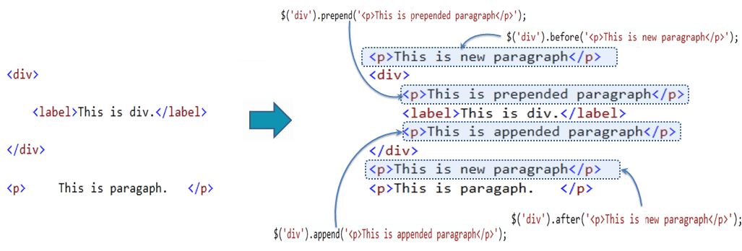](https://www.tutorialsteacher.com/Content/images/jquery/manipulation-methods.png)

## **jQuery after() Method**

The jQuery after() method inserts content (new or existing DOM elements) after target element(s) which is specified by a selector.

**Syntax:**

$('selector expression').after('content');

**Example: jQuery after() Method**

$('#div1').after('<div style="background-color:yellow"> New div </div>');

<div id="div1">div 1

</div>

<div id="div2">div 2

</div>

## **jQuery before() Method**

The jQuery before() method inserts content (new or existing DOM elements) before target element(s) which is specified by a selector.

Syntax:

$('selector expression').before('content');

Example: jQuery before() Method

$('#div1').before('<div style="background-color:yellow"> New div </div>');

<div id="div1">div 1

</div>

<div id="div2">div 2

</div>

**jQuery append() Method**

The jQuery append() method inserts content to the end of target element(s) which is specified by a selector.

Syntax:

$('selector expression').append('content');

Example: jQuery append() Method

$('p').append('World!');

<p>Hello </p>

**jQuery prepend() Method**

The jQuery prepend() method inserts content at the beginning of an element(s) specified by a selector.

Syntax:

$('selector expression').prepend('content');

Example: jQuery prepend() Method

$('div').prepend('<p>This is prepended paragraph</p>');

<div>

<label>This is div.</label>

</div>

## **jQuery remove() Method**

The jQuery remove() method removes element(s) as specified by a selector.

Syntax:

$('selector expression').remove();

Example: jQuery remove() Method

$('label').remove();

<div>This is div.

<label>This is label.</label>

</div>

**jQuery replaceAll() Method**

The jQuery replaceAll() method replaces all target elements with specified element(s).

Syntax:

$('content string').replaceAll('selector expression');

Example: jQuery replaceAll() Method

$('<span>This is span</span>').replaceAll('p');

<div>

<p>This is paragraph.</p>

</div>

<p>This is another paragraph.</p>

**jQuery wrap() Method**

The jQuery wrap() method wrap each target element with specified content element.

Syntax:

$('selector expression').wrap('content string');

Example: jQuery wrap() Method

$('span').wrap('<p></p>');

<div>

<span>This is span.</span>

</div>

<span>This is span.</span>